Communication Route  Tel: 0392176298  Website: www.nwoya.go.ug  E-Mail : nwoya2010district@gmail.com  Incase of any correspondence on this subject matter Please quote: CR |  | NWOYA DISTRICT LOCAL GOVERNMENT  Office of the Chief Administrative Officer  P. O. Box 1033, Gulu  UGANDA  Date:……………………………

The Chief Administrative Officer
Nwoya District Local Government
RE: REPORT ON SUPERVISION AND DOCUMENTATION OF EMYOOGA BENEFICIARIES SUCCESS STORIES:

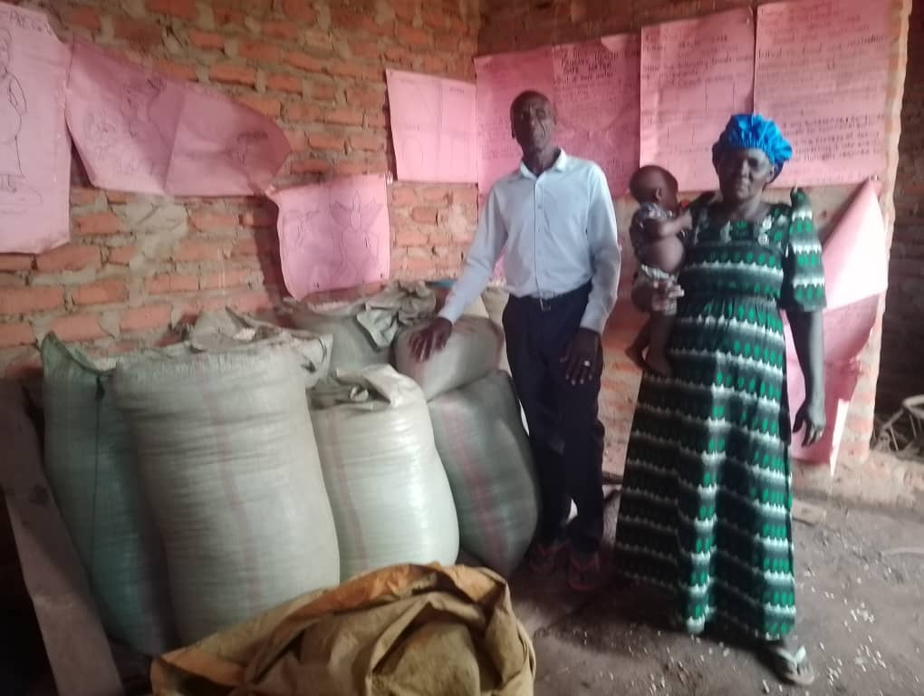
Opiyo George Men, a beneficiary of emyooga seed capital under Nwoya East PWD, in Lii sub-county.

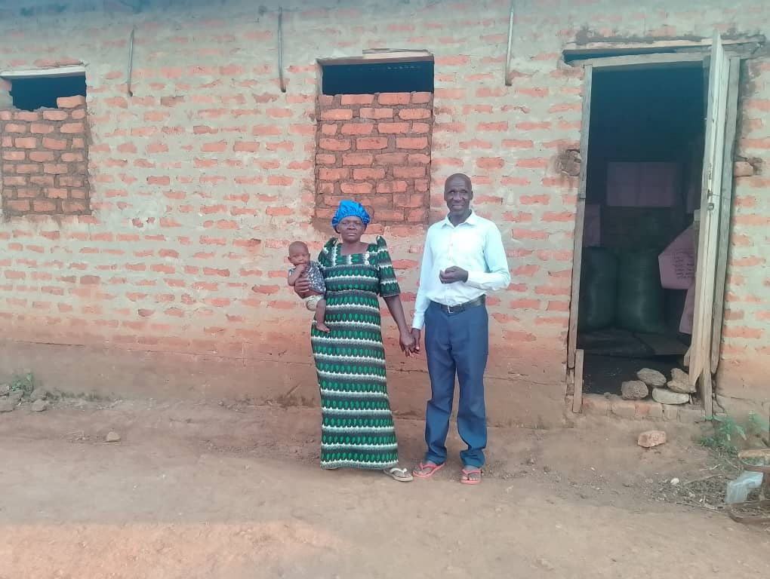
Opiyo George (blind man/sight impairment) and his wife in front of their unfinished building. He got Ugx.3m and bought dairy cow, for 2m and 1m injected in maize and soy bean production. The proceeds from the milk, maize and soy bean sales was injected into the construction of this building.
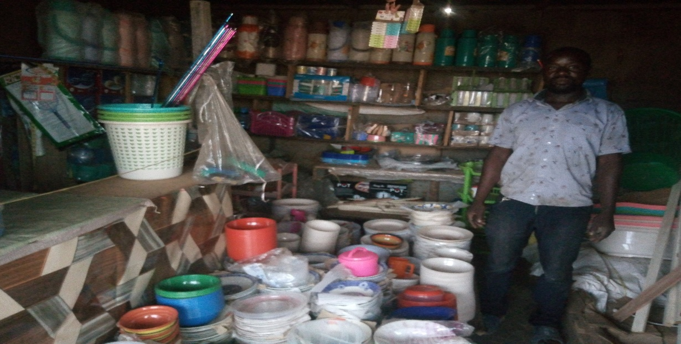
Kizza Jack , a beneficiary of emyooga seed capital under Nwoya East restaurant owners in Alero center ,selling Cooking and house hold utensils
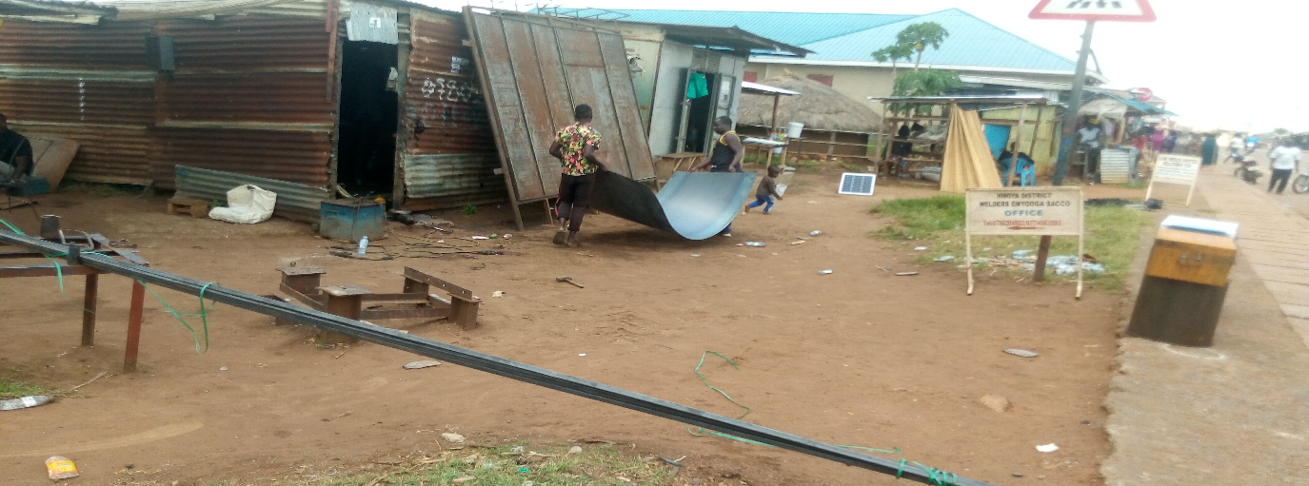Nwoya Welders Omyooga SACCO office, located near Real Paradise metal and Fabrication workshop c/o Odokonyero Jacob tel.0780204922 (Chairperson/beneficiaries’ work shop in Anaka TC ) Nwoya District.
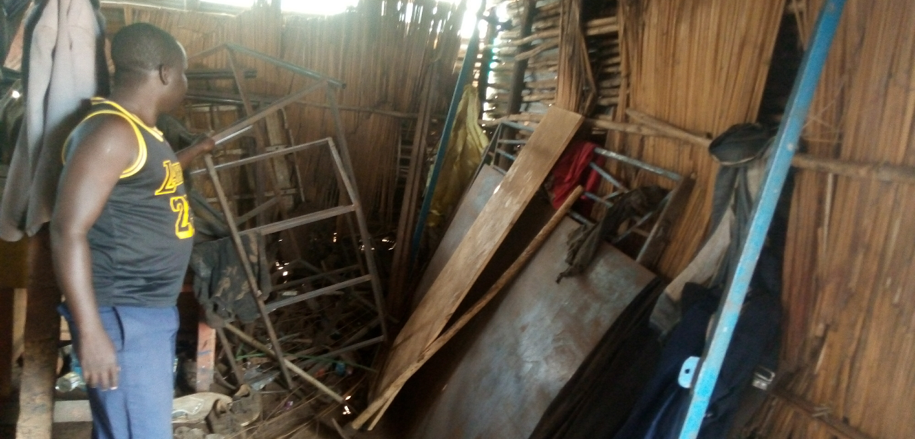
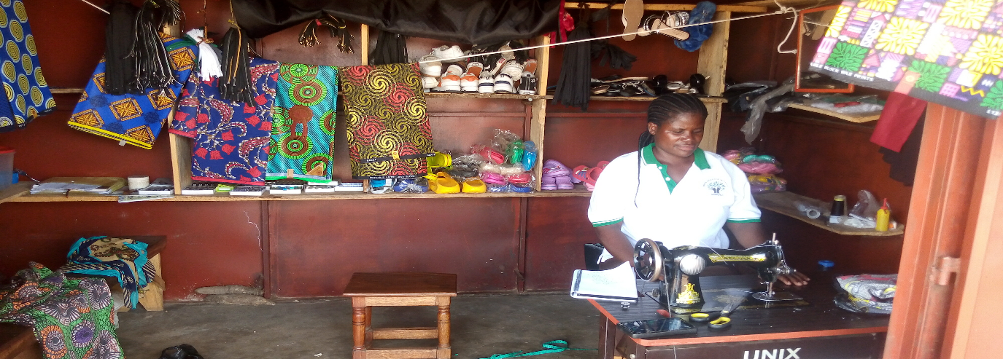Jenniffer Lagweno Apiyo tel. 0774504865 , emyooga beneficiary under PWD SACCO, Anaka TC in her boutique container. She bought kitenge materials and second hand shoes to boost her business, using the seed capital to boost her business.
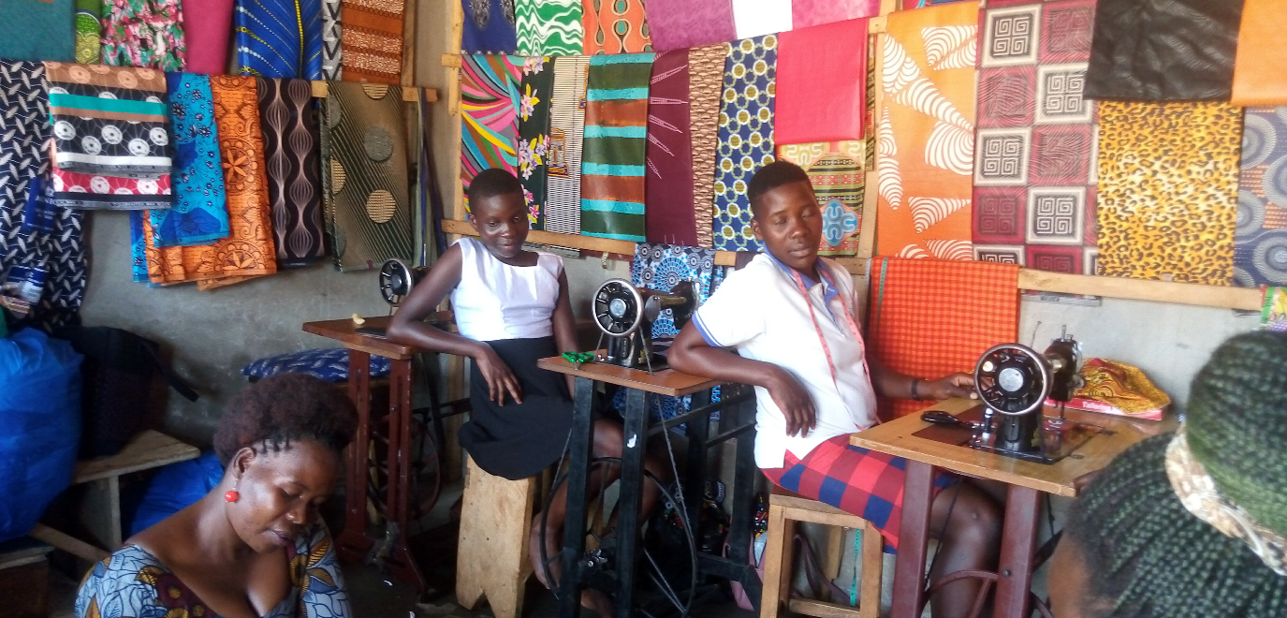
Adong Aisha,seated on the floor, tel. 0771213790 a beneficiary of emyooga SACCOS under Tailoring category located at Aciro concy road,Anaka Town council.
- She started on her own with Ugx. 500,000 in 2014.
- Got emyooga seed capital loan of Ugx. 3,000,000 in 2022 and bought 2 new sewing machines and more stock of kitenge materials, now making good profit of at least 100,000 per day and sometimes during festive seasons,200,000/=
- Also, training some young girls on seasonal basis, 4 at a time.
- Started constructing a small residential building of 2 bed rooms, but not yet finished.
- Paying school fees at secondary and primary schools.
Future Plan;
- Acquire a designer machine
- Acquire electric machine for speed and efficiency
- Whole sale shop for garment materials
Challenges; low sales, high prices of garment materials
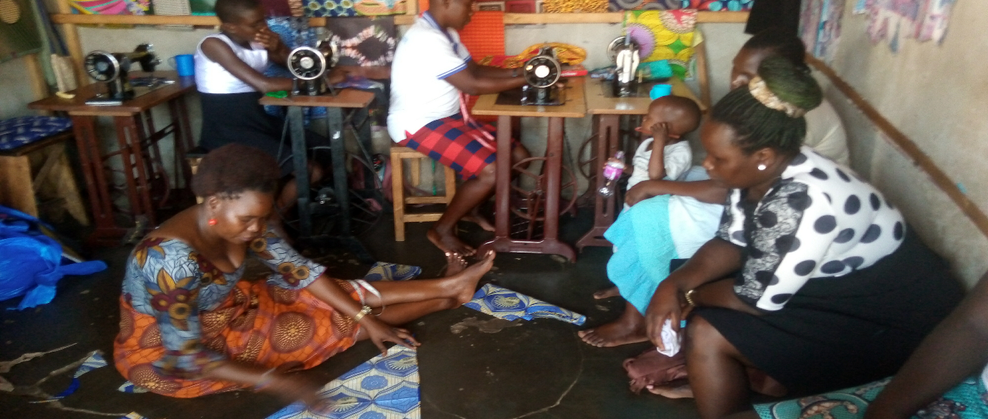
Adong Aisha, emyooga tailoring SACCOS beneficiary,seated and cutting clothe on the floor.
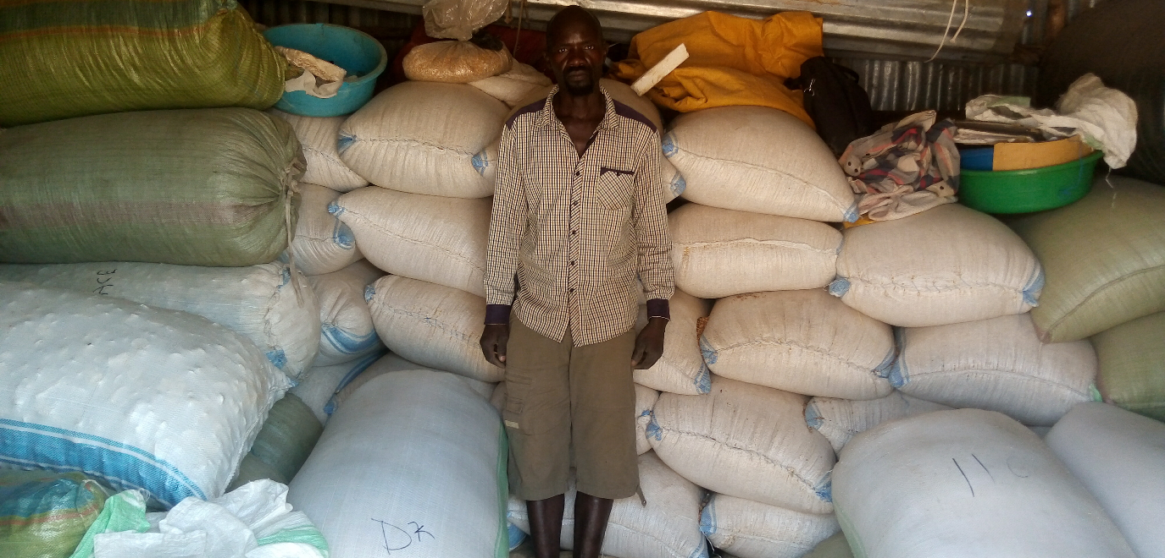
Lokodamoi Denis, standing in his store in Anaka, an emyooga seed capital beneficiary under Produce buyers emyooga SACCOS. He has been getting Ugx.900,000 three times to boost his produce business.
Story:
- Business is growing
- Paying school fees for the children at schools.
- Boought commercial plot at Anaka TC
- Rearing chicken and goats as a backup income generating investment
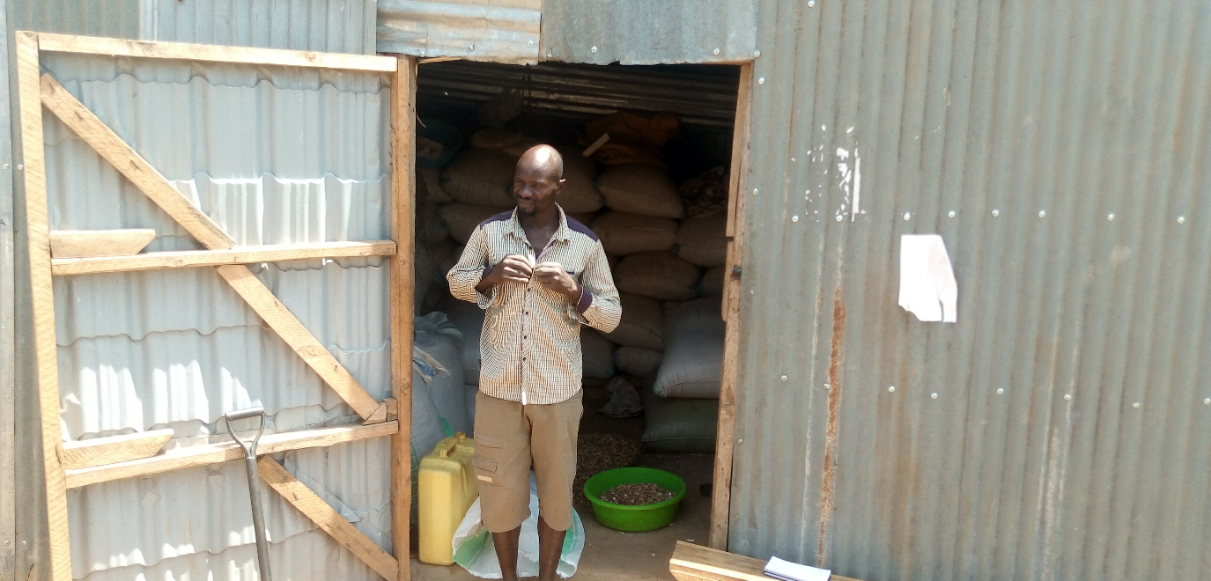
Lokodamoi Denis,produce dealer,emyooga beneficiary at his store.
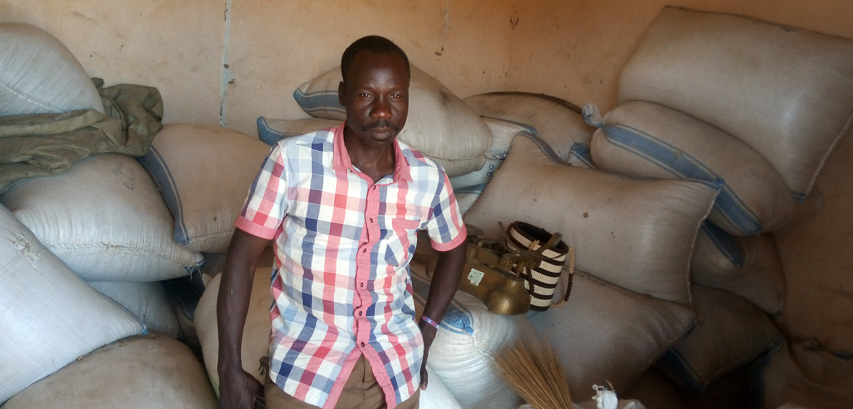
Lukwiya David tel. 0774460939 located at Aciro Concy road. A produce dealer and the chairperson of Nwoya Produce Dealers emyooga SACCOS . Got 1.5m from emyooga SACCOS and other stock came from his garden(30 bags of maize/gnuts). Has 7 tons of maize and gnuts in the store currently.

Story;
- Bought 4 acres of farm land at 4m.
- Bought 6 goats for multiplication/business
- Dressing well more than before.

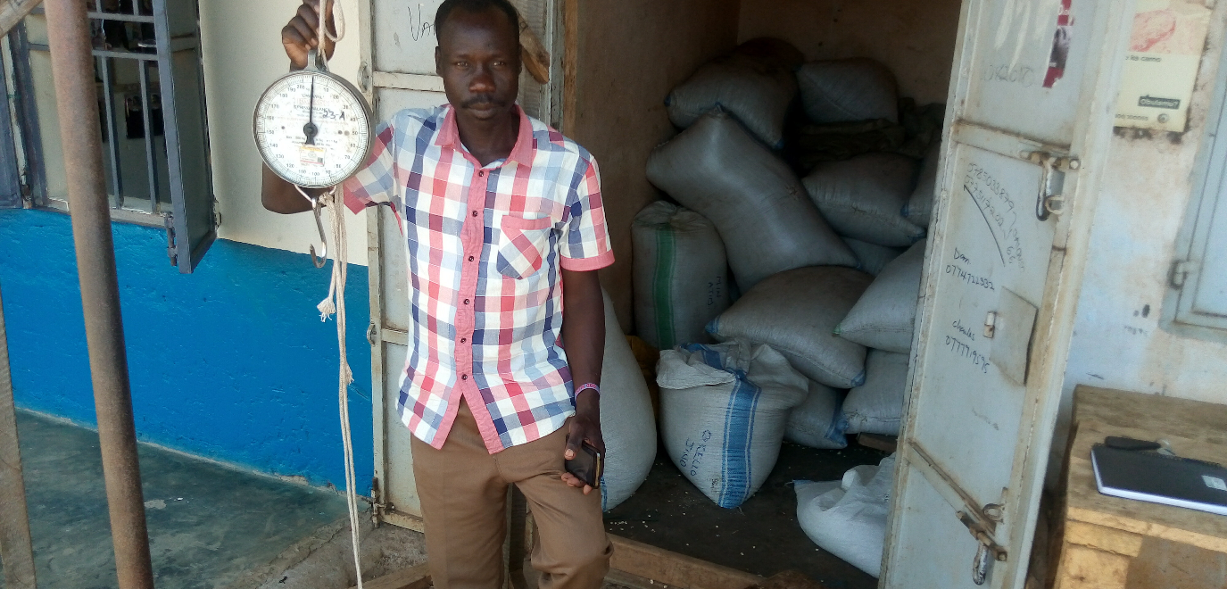
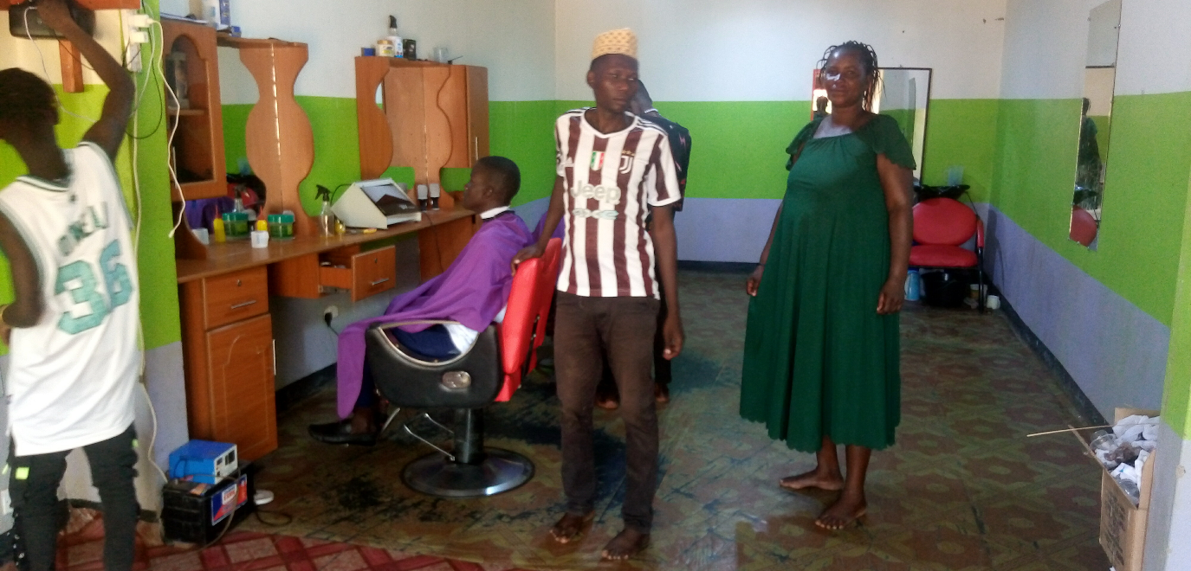
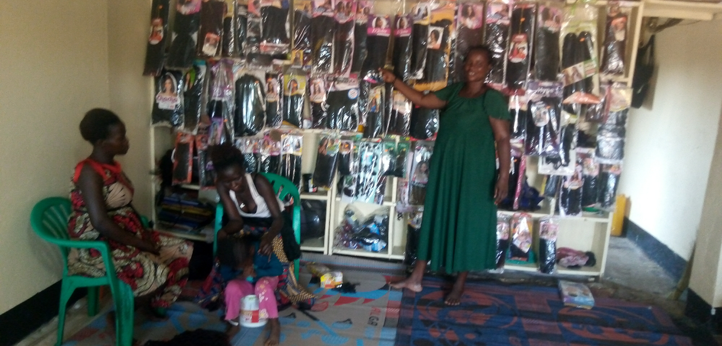
Akwero Everlyn tel. 0764667729, a beneficiary of emyooga seed capital under saloon operators. She got Ugx. 3,000,000 from emyooga SACCOS to buy weaves and barber chairs to boost her saloon business located along Gulu- Olwiyo high way,Anaka TC.
Story:
- Started in 2018 with a capital of Shs. 24,000 under a tree.
- Had skilling in hair dressing
- Got emyooga seed capital in 2021 and bought stocks of weaves and electronic dryer
- Expanded to barber saloon, bought chairs
- Paid her daughter in the University and she is now helping to keep good record of the business.
- Started making chapatti as additional investment that gives her ugx. 30,000 daily.
- Investing in farming maize and cassava
- Bought a commercial plot at Lukai trade center at 1.3m
Built a commercial building at Lukai,almost complete.
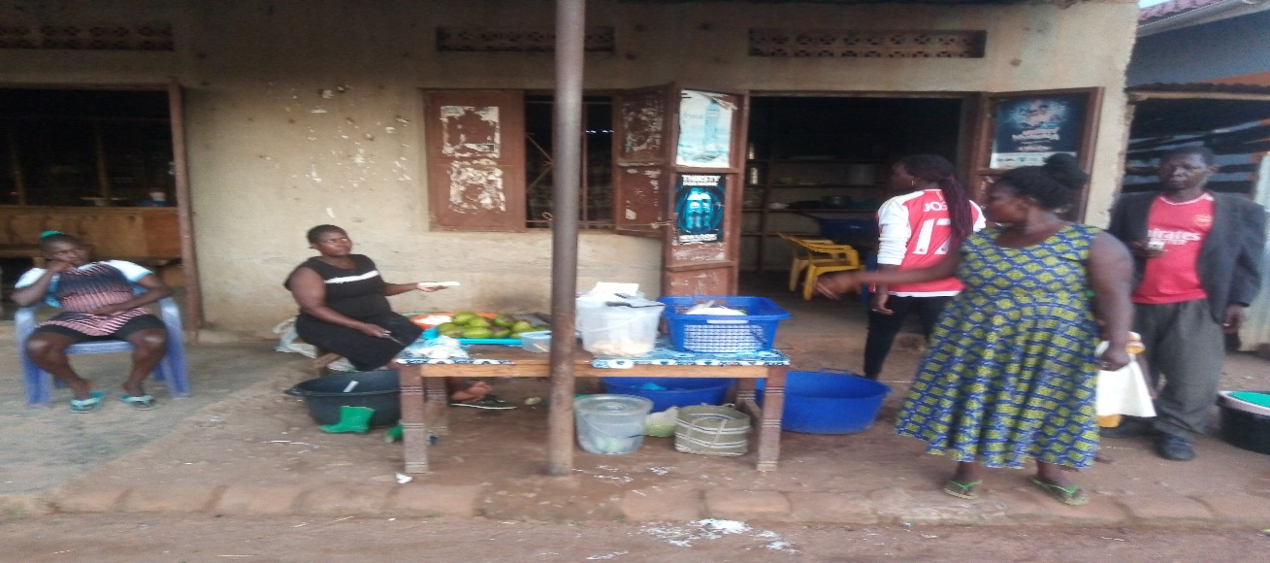
Mego Santa in front of her restaurant in Alero center, showing the products the restaurant offers to her customers.
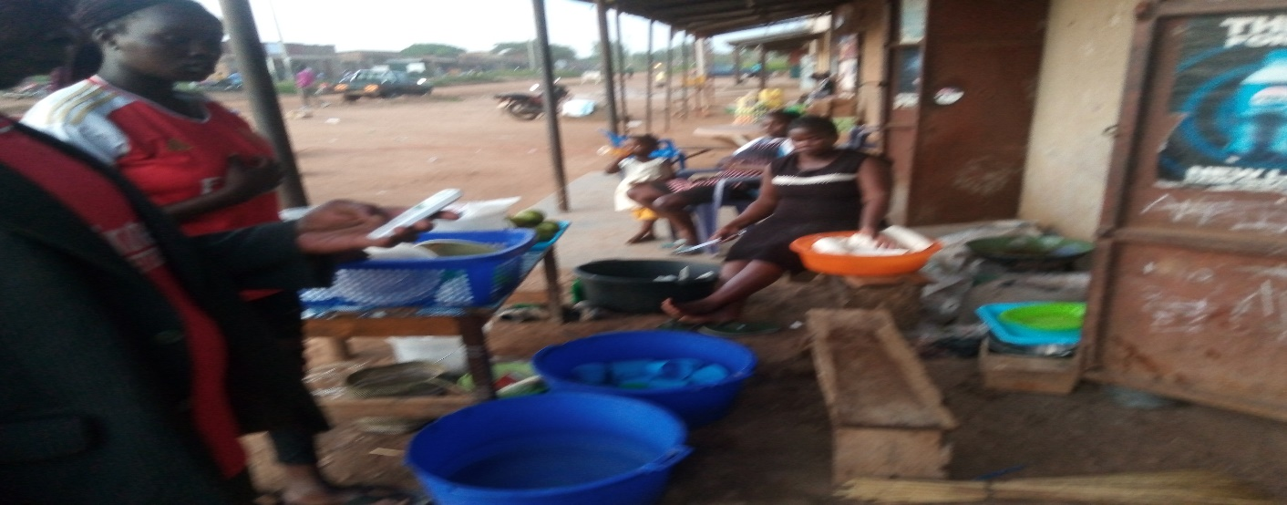
Market vendors in Alero center, they supply food on a daily basis to the restaurants and other customers. 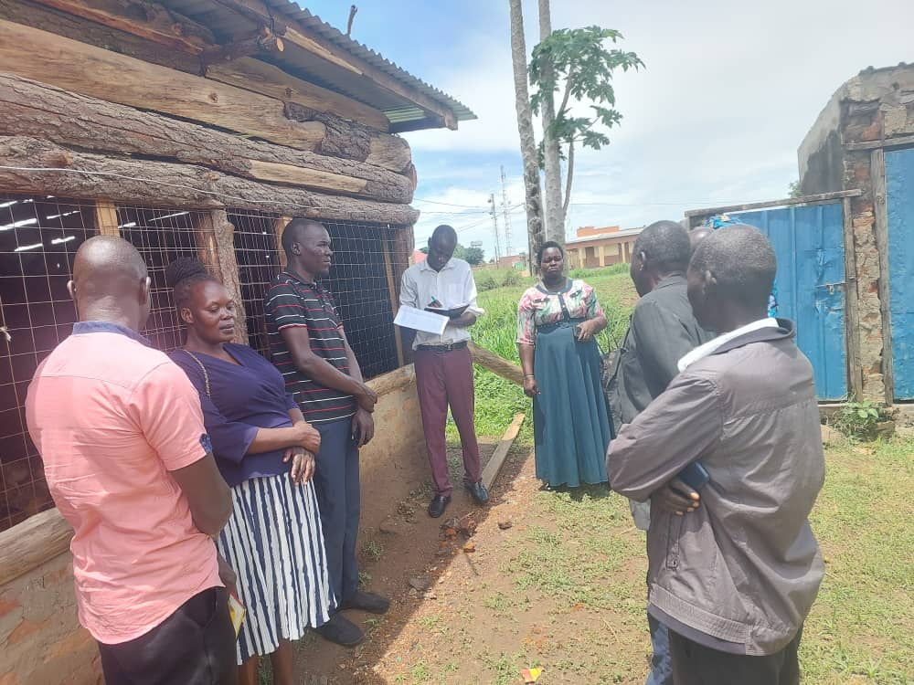
Council committee members at Nwoya veterans Emyooga SACCO members joint poultry project at Anaka Town council.

Challenges;
- Products/material costs are high and yet customers need cheap and affordable things
- Tax, Town council charges;Ugx.180,000 and URA Ugx.160,000

General Challenges:
- Lack of proper record keeping. Most beneficiaries do not keep good track of their businesses and the outcomes.
- Bad roads. Some beneficiaries are located far away from accessible roads.
- Produce dealers, women council entrepreneurs and Youth SACCOS have overwhelming members that is far beyond the seed capital received. So, the seed capital is inadequate for them.
- Most of the Emyooga SACCOS have closed their office space due to rental challenges/unable to pay every months.
- Poor loan recovery, at 22 % only. Loan delinquencies is at higher rate.

Compiled by:
Kitara Kenneth
Senior Commercial Officer
cc. Resident District Commissioner/Nwoya
cc. District Chairperson/Nwoya
cc. District Commercial Officer/Nwoya

